Installation Guide

jWebSocket
API for smart card management
v 1.0

Version Control
Date | Version | Description | Author
21/02/12 | 1.0 | Document Creation | Marta Rodríguez Freire

1. Download application process
The download process API for smart card management is done downloading all the packages containing the client and server jWebSocket contained in version 1.0 from the URL: http://jwebsocket.org/download/.
2. Characteristics of the installation environment
- OpenJDK 1.7 or higher installed.
- Card reader that support the standard PC / SC
3. Install process
To use the API for smart card management should be able to run the applet in the browser, the client must have Java installed.
Install for the Linux operation system:
- Change the permissions of the downloaded file to be executable. Write:
chmod a+x jre-6u<versión>-linux-i586.bin
- Check that you have permission to run file. Write:
ls –l
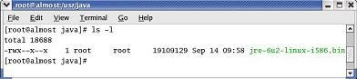

- If you want change the directory where you want to install. Write
cd <ruta de acceso al directorio>
For example, to install in the directory /usr/java. Write:
cd /usr/java/
Note about root access: To install Java in a location accessible from the entire system, such as/usr/local, you must login as root to obtain the necessary permits. If you don’t have root access, install Java in your home directory or a subdirectory for which you have write permission.
- Run the self extracting binary. Write
./jre-6u<versión>-linux-i586.bin
Shows the license agreement, review the contract. Press the spacebar to move to next page. In the end, write yes to proceed with the installation.
- Java is installed in its own directory. In this example, it has been installed in the /usr/java/jre1.6.0_<versión>. Once the installation is over will see the word Done.
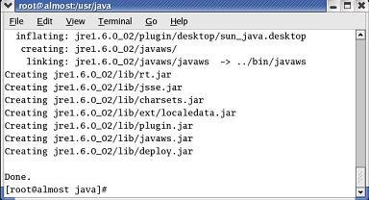

- Check that the subdirectory jre 1.6.0 appears in the content from the current directory. Write: ls
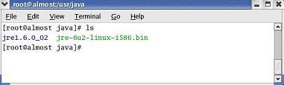

Install for the Windows operation system:
- Close all applications, including the browser.
- Double click the file to start the installation process.
- Starts the installation process. Click the Install button to accept the license terms and continue with the installation.
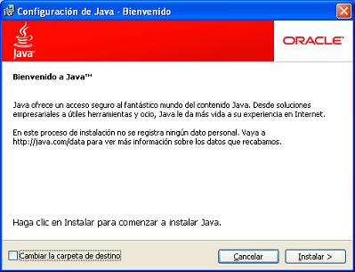

- Oracle works with companies offering different products. It is possible that the installer offers the option to install these programs as part of the Java installation. Once selected the programs you want, click the Next button to continue the installation process.
- It is open several dialog boxes with information to complete the final stages of the installation process, click Close on the last dialog box. This action will complete the installation of Java.
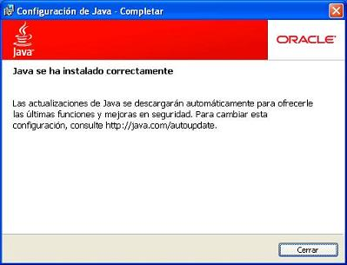

NOTE: You may need to restart (close and open) your browser to enable the installation of Java on your browser.
3.1 Application specific hardware
For production environments must be available smart card reader that supports the standard PC / SC.
4. Configuration Options
Don´t require any specific configuration

5. In Runtime
Server
- Run the jWebSocket server
Client
- Connect the card reader on the client station
- Run the applet in the client browser

6. Management of the Application
To manage API for the management of smart cards can be supported in the user guide.

